ST. CARTHAGH CATHOLIC SCHOOL
JUNE UPDATE

Terrific Kids-Our assembly was held on May 24th and our virtue was, A Discerning Believer. The following students were recognized: Riley Vilneff, Avery White, Brodeigh Pym, Barbara Selmys, Cynthia Conner, Ayden Else and David Alberta! A special thank you to our friends at Tweed Kiwanis for their amazing support throughout this school year.

Gr. 8 Graduation
Gr. 8 Graduation is scheduled for Monday, June 25th beginning with Mass at 6:30 p.m. followed by awards & certificates. Invitations will be sent home soon.

Thank You to Our Volunteers
We are blessed to have parents, grandparents, parish, community members and students who volunteer in many ways. Many hands make light work and we thank you all!!

St. Carthagh Parent Council
We would like to thank our Parent Council for their continued cooperation and support throughout the year. Through their hard work with the “12 Days of Christmas” raffle, two years of transportation costs for field trips have been subsidized which is a great savings for our families. Their contributions make a difference for our students. We encourage parents to join this dynamic group, we are always looking for new ideas and energy.

Welcome to Kindergarten
On Monday, June 18th from 5:30-6:30 p.m. Kindergarten students who are registered for September 2018, and their parents, are invited to our Kindergarten Orientation. An invitation will be sent to families. Also, Gateway Community Health Centre is offering a “Kindergarten Readiness Program”. This will occur in the JK/SK classroom in August from 9-11:30 a.m. This program focuses on establishing classroom routines and making the transition smoother. If you are interested please call George at 613-478-1211. More information will be available the night of orientation.

September 2017
As of now, our next year class assignments are as follows. Please note this is subject to change based on enrollment and staffing.
Kindergarten-Mrs. DeMille & Mrs. Gunter, Gr. 1-Mrs. Cassidy, Gr. 2/3-Mrs. Montgomery, Gr. 4/5-Miss Black, Gr. 5/6-Mr. Aarts, Gr. 7/8-Mr. Allore, SERT-Mrs. Farrell, FSL-Mr. Francoeur.

Saying Goodbye
As our year draws to a close we would like to acknowledge some staffing changes. Miss Allen, Mrs. Farrington and Miss Brittany Sagriff have completed their positions with us. We wish them well and will miss their many talents and smiling faces.

Pizza/Milk Orders
There will be no pizza or milk orders the last week of June. This allows us time to clean our fridges and finalize our banking. Thank you for supporting these programs as the funds directly support our students.

Thanks to all staff, students, parents, community members and parish members for another great school year!
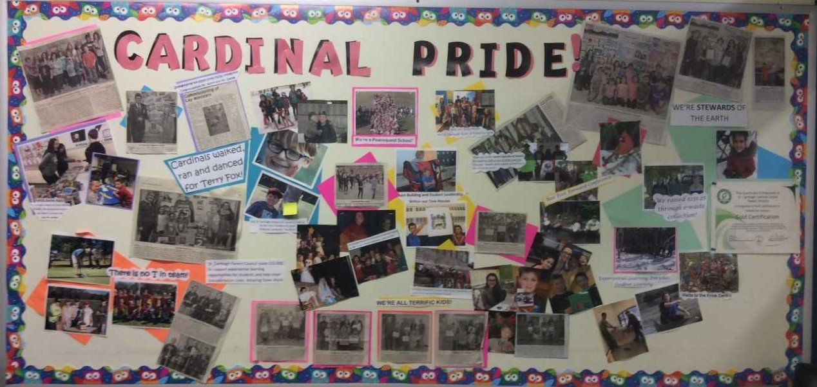

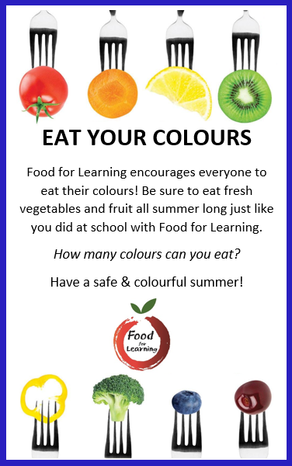
Learning French is Fun!
“I love my teacher because she teaches French.”
Charlotte, ALCDSB Grade 1 Student
Encourage your child to be a lifelong learner of French!

 | June 2018
Sun | Mon | Tue | Wed | Thu | Fri | Sat
 |  |  |  |  | 1  Girl’s Night In, St. Theresa, Gr. 8’s  GCHC Jazz Band Concert Presentation, Gr. 4-8 | 2
3 | 4  School Track & Field & BBQ | 5  Montgomery/Farrell Lang Pioneer Village | 6  Milkshake Day | 7  Papa John’s Pizza  Ms. Allen Boiler Room Trip  Gr. 8 Transition Mtg | 8 | 9
10 | 11 | 12  Mr. Allore Queen’s Trip | 13  Milkshake Day  Piano Recital 1:30 | 14  Papa John’s Pizza  Gr. 3/4 Soccer | 15  Board Track & Field | 16
17 | 18  Kindergarten Orientation 5:30-6:30 | 19 | 20  Milkshake Day | 21  Papa John’s Pizza-last day  Terrific Kids 9:30 | 22  Last Day for Milk  School Mass 9:30  DeMille/Cassidy Sandbanks Trip  Appreciation Social | 23
24 | 25  Graduation 6:30 | 26  Montgomery/Farrell Quinte Wellness Trip  Leadership Training (a.m.) Gr. 6/7 | 27  Milkshake Day  Leadership Training (a.m.) Gr. 6/7 | 28  Last Day of Classes-Report Cards go Home | 29  PA Day | 30

